**How to Calibrate Motors**

**ESC Calibration**

Electronic speed controllers are responsible for spinning the motors at the speed requested by the flight controller (i.e. APM or PX4). Most ESCs need to be calibrated so that they know the minimum and maximum pwm values that the flight controller will send.  This page provides instructions for calibrating ESCs.

**About ESC Calibration**

ESC calibration will vary based on what brand of ESC you are using, so always refer to the documentation for the brand of ESC you are using for specific information (such as tones).  “All at once” calibration works well for most ESCs, so it is good idea to attempt it first and if that fails try the “Manual ESC-by-ESC” method.

* For 3DR ESCs can use the “All at once” method.
* DJI Opto ESCs do not require and do not support calibration, so skip this page completely
* Some brands of ESC do not allow calibration and will not arm unless you adjust your radio’s throttle end-points so that the minimum throttle is around 1000 PWM.  Note that if you change the end-points on your TX you must re-do the [Radio Calibration](http://copter.ardupilot.com/wiki/initial-setup/esc-motor/wiki/initial-setup/configuring-hardware/#Calibrate_radio_control).
* Begin this procedure only after you have completed the “[Calibrate radio control](http://copter.ardupilot.com/wiki/initial-setup/esc-motor/wiki/configuring-hardware/#Calibrate_radio_control)” section of the [Configuring Hardware](http://copter.ardupilot.com/wiki/initial-setup/esc-motor/wiki/configuring-hardware) page and “[Connect ESCs and motors](http://copter.ardupilot.com/wiki/initial-setup/esc-motor/wiki/assembly-instructions/#Connect_ESCs_and_motors)” part of the [Assembly Instructions](http://copter.ardupilot.com/wiki/initial-setup/esc-motor/wiki/assembly-instructions/).  Next follow these steps:

**All at once calibration**

**Safety Check!**

Before calibrating ESCs, please ensure that your copter has NO PROPS on it and that the APM is NOT CONNECTED to your computer via USB and the Lipo battery is disconnected.

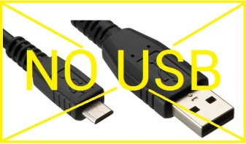

1. Turn on your transmitter and put the throttle stick at maximum.  
   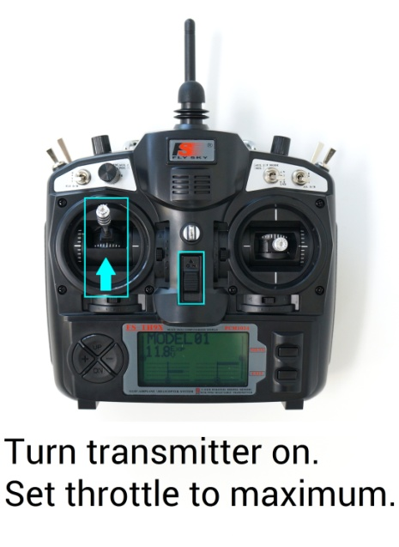
2. Connect the Lipo battery.  On an APM the red, blue and yellow LEDs will light up in a cyclical pattern. This means the APM is ready to go into ESC calibration mode the next time you plug it in.  
   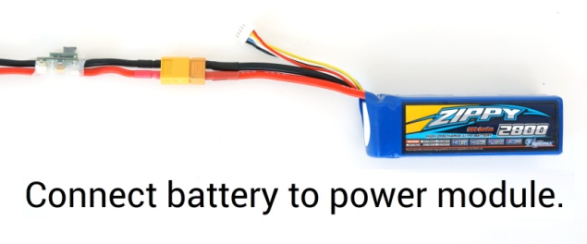
3. With the transmitter throttle stick still high, disconnect the LiPo battery.  
   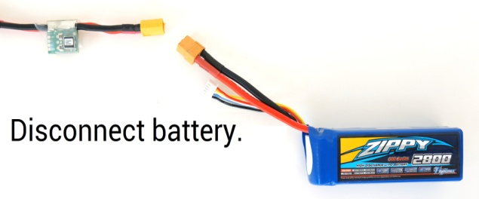
4. With the transmitter throttle stick still high, Reconnect the Lipo battery.  
   
5. (For a **PX4** press and hold the Safety button for 5 seconds to disengage the safety).
6. The APM/PX4 is now in ESC calibration mode. (On an APM you may notice the red and blue LEDs blinking alternatively on and off like a police car).
7. Wait for your ESCs to emit the musical tone, the regular number of beeps indicating your battery’s cell count (i.e. 3 for 3S, 4 for 4S) and then an additional two beeps to indicate that the maximum throttle has been captured.
8. Pull the transmitter’s throttle stick down to its minimum setting.  
   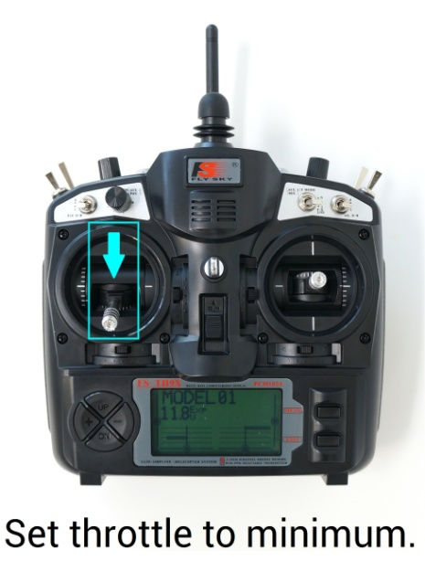
9. The ESCs should then emit a long tone indicating that the minimum throttle has been captured and the calibration is complete.
10. If the long tone indicating successful calibration was heard, the ESCs are “live” now and if you raise the throttle a bit they should spin.
11. Test that the motors spin by raising the throttle a bit and then lowering it again.
12. The APM is still in ESC calibration mode and before flying you will need to return it to regular flight mode.
13. To enter normal flight mode directly from ESC calibration mode, put the throttle low and disconnect and reconnect the battery.
14. (For a **PX4** you will also need to depress and hold the Safety button for 5 seconds to disengage the safety to be able to arm).